Network Cables and Connectors
Task – 1 : Draw a labeled diagram of a Cat6 Ethernet cable, showing the color order of wires in the T568B standard and labeling the RJ-45 connector pins.
Solution : Cat6 Ethernet Cable and RJ-45 Connector
A Cat6 Ethernet cable is a twisted-pair network cable commonly used to connect computers, switches, routers, access points, and other network devices.
Cat6 contains 4 twisted pairs = 8 individual wires. For an RJ-45 connector, the wires are arranged according to a standard such as T568B.
T568B Color Order
When looking at the RJ-45 plug with the contacts facing you and the locking clip facing away/down, the pin order is:
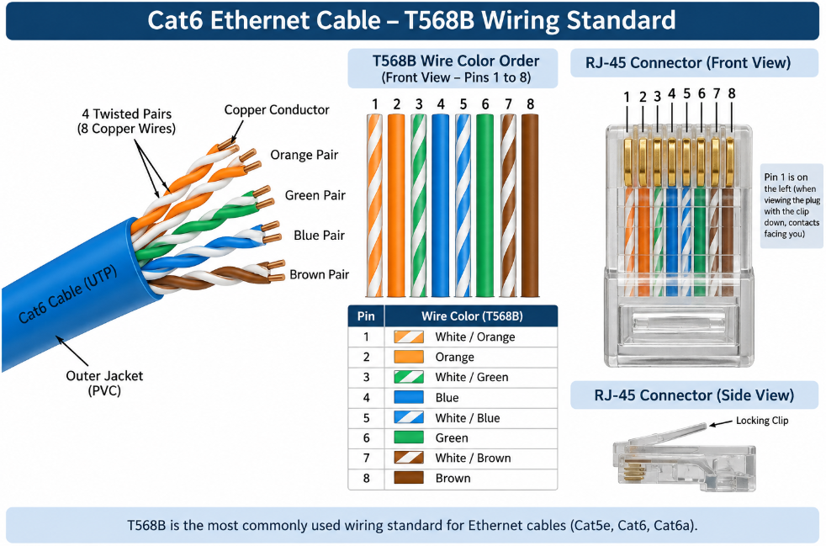
RJ-45 Connector
T568B Pinout Table
Pin | Wire Color | Pair
1 | White/Orange | Orange
2 | Orange | Orange
3 | White/Green | Green
4 | Blue | Blue
5 | White/Blue | Blue
6 | Green | Green
7 | White/Brown | Brown
8 | Brown | Brown

Task – 2 : List three types of network cables (such as Cat5e, Cat6, and fiber optic) and for each, mention one real-world app or device (like a WiFi router, Zomato POS terminal, or IPL streaming server) where it would be used, explaining why.
Solution : Types of Network Cables
1. Cat5e Ethernet Cable
Cat5e is a twisted-pair copper Ethernet cable commonly used in local networks.
Example : Wi-Fi Router → Laptop
It can be used to connect a laptop or desktop to a router/switch. It is inexpensive and suitable for many home and office networks.
2. Cat6 Ethernet Cable
Cat6 is an improved twisted-pair Ethernet cable designed for higher-speed networking and better resistance to interference than older categories.
Example : Gaming PC → Network Switch
It is useful in gaming zones, offices, and other LAN environments where high-speed and reliable wired connectivity is required.
3. Fiber Optic Cable
Fiber optic cable transmits data using light signals through optical fiber rather than electrical signals.
Example : ISP → Data Center
Fiber is suitable for high-speed and long-distance connections. Internet service providers and data centers commonly use fiber for high-capacity network links.
Comparison
Cable | Transmission | Example | Why Used
Cat5e | Electrical signals | Router → Laptop | Affordable and suitable for normal LAN use
Cat6 | Electrical signals | Gaming PC → Switch | Higher-speed and reliable LAN connections
Fiber Optic | Light signals | ISP → Data Center | Very high speed and long-distance communication

Task – 3 : Watch a YouTube video showing how to crimp an RJ-45 connector onto a network cable, then write down the step-by-step process in your own words and mention two common mistakes to avoid.
Solution : RJ-45 Crimping Process
- Cut the cable: Cut the Ethernet cable to the required length.
- Strip the jacket: Remove about 2–3 cm of the outer insulation.
- Untwist the wires: Separate and straighten the 8 wires.
- Arrange the wires: Follow the T568B order:
White/Orange → Orange → White/Green → Blue → White/Blue → Green → White/Brown → Brown
- Trim the wires: Make all wires equal in length.
- Insert into RJ-45: Insert all 8 wires in the correct order.
- Check: Ensure all wires reach the end of the connector.
- Crimp: Place the connector in the crimping tool and press firmly.
- Test: Use a cable tester to verify the connection.
Common Mistakes
- Incorrect wire order.
- Wires not fully inserted into the connector.

Task – 4 : Given the following scenario: You are setting up a gaming zone for an IPL screening event and need to connect multiple screens and consoles. Choose the appropriate cable and connector types for high-speed, reliable connections, and explain your choices.
Solution : Gaming Zone for IPL Screening Event
For connecting multiple gaming consoles, PCs, and network switches, I would choose Cat6 Ethernet cable with RJ-45 connectors.
Cat6 provides a reliable wired connection with low latency and is suitable for high-speed LAN communication. Wired Ethernet is preferable for gaming because it avoids some of the interference and variability that can occur with Wi-Fi.
Cable and Connector Choices
Component | Choice | Reason
Gaming devices | Cat6 Ethernet | Fast and reliable wired connection
Network switch | Gigabit Ethernet switch | Connects multiple gaming devices
Connector | RJ-45 | Standard connector for copper Ethernet
Router → Switch | Cat6 Ethernet | High-speed network connection
Screens | HDMI/DisplayPort | Carries video from console/PC to display

Explanation
Cat6 Ethernet cables with RJ-45 connectors are appropriate for the network connections between the router, switch, and gaming devices. They provide stable, low-latency communication and are easy to install. HDMI or DisplayPort should be used separately for connecting consoles/PCs to the screens because Ethernet carries network data, not the normal display signal.

Task – 5 : Find and share a photo (from your home, college, or online) of any network cable or connector in use (such as behind a WiFi router or at a café's POS counter), and describe what type it is and what devices it connects. Hint : Look for blue or yellow cables with clear plastic ends (RJ-45) or thin round cables for fiber optics.
Solution : Photo of a Network Cable or Connector
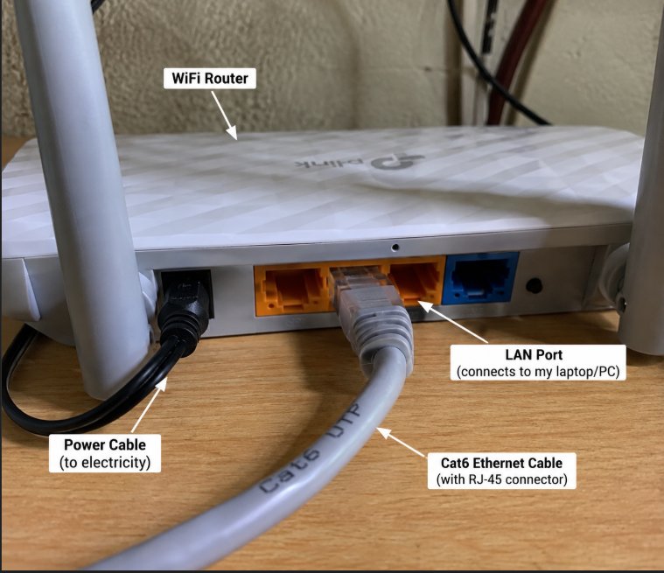
Network Cable
The cable shown in the photograph is a Cat6 Ethernet cable with an RJ-45 connector. It is connected to the LAN port of a Wi-Fi router and is used to provide a wired network connection to another device such as a laptop or computer. The RJ-45 connector contains eight contact pins that connect to the eight wires inside the Ethernet cable. The cable carries network data between the connected devices.

